**Layman terms (in order of progressive understanding)**

*Muon Tomography:*

Muon tomography is a non-destructive imaging technique that uses cosmic muons to create 3D images of dense objects, such as volcanoes, mountains, and even archaeological sites. Muons are subatomic particles that are created in the upper atmosphere by cosmic rays and constantly rain down on the Earth. As muons pass through matter, they interact with the atomic nuclei and produce a detectable signal. By measuring the angle and intensity of the muon flux, researchers can reconstruct a 3D image of the object being studied. This technique is particularly useful for imaging objects that are difficult to study using traditional methods, such as x-rays and ultrasound.

*ML in Muon Tomography:*

Machine learning can be applied to muon tomography to improve the accuracy and efficiency of the imaging process. ML algorithms can be trained on simulated muon data to identify and classify muon interactions, and to reconstruct the 3D image of the object being studied. This can lead to faster and more accurate imaging and can also help to reduce the amount of data required to produce high-quality images.

*Muon Track Reconstruction Using ML:*

Muon track reconstruction using machine learning involves using neural networks to reconstruct the trajectories of muons as they pass through a particle detector. This technique has applications in high-energy physics experiments, where muons are produced in large numbers and need to be reconstructed quickly and accurately in order to study the properties of particles and their interactions. By training a neural network on simulated muon data, researchers can improve the accuracy of muon track reconstruction and reduce the computational resources required.

*Material Discrimination and Identification Using Cosmic Muons:*

Cosmic muons can be used to identify and discriminate between different materials based on their density and atomic composition. By measuring the rate and intensity of cosmic muons passing through a material, researchers can infer the material properties and identify any anomalies or irregularities. This technique has applications in fields such as geology, archaeology, and materials science, where it can be used to study the properties and composition of materials without damaging or destroying them.

**What we will be working on**

Our team will be primarily focused on muon track reconstruction using ML. Our primary goal is to improve the accuracy of determining the position of muon strikes and reconstruct muon tracks using machine learning algorithms to identify and reconstruct the trajectory of muons as they travel through a particle detector. This is a complex task because muons can interact with the detector material and produce a range of signals that must be interpreted correctly to reconstruct their paths.

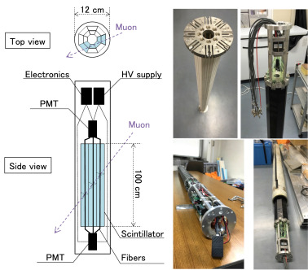

The image above shows a detector that is bombarded with muons. When a muon strikes a specific point on the scintillator with a distance x from a particular PMT and 100-x from the second PMT, there is a potential for inaccuracy in the measurement of x (represented by m). This can result in higher errors when multiple detectors (y) are connected in line (m*y). The electronics connected to the PMT records the time (t1, t2) and energy transferred (q1, q2) for each event. By analysing a large volume of data for t1, t2, q1, and q2, it may be possible to reduce the error in calculating x. Additionally, for a complete 3D image, the calculation of the position in the z direction will also be required.

We will be creating multiple models for the detector using time and energy as variable using ml as to lower the m.

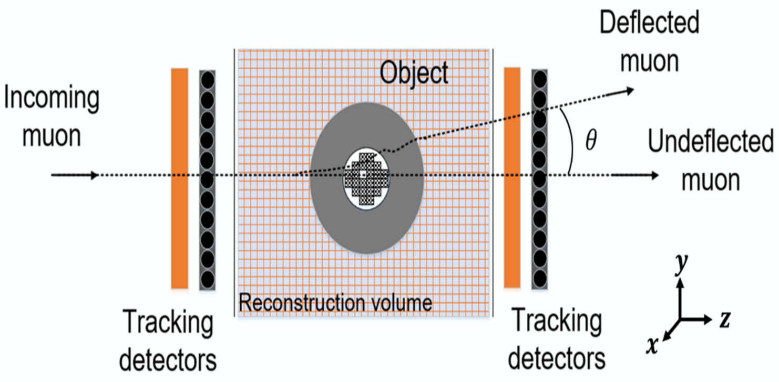

Above is a sample image on how tracking the muon passing through the two detectors can be used to construct an image of the particle.

**Where it will be used**

Muon tomography is particularly useful for imaging inside of dense environments where other techniques like x-rays and ultrasound fall short. One such environment is a nuclear reactor. CCTV cameras cannot be used to inspect the internal components of the reactor because the high levels of radiation emitted by nuclear reactors can damage or destroy electronic equipment. Muon tomography can generate 3D images of the internal components of the reactor without the need for direct access to the components, making it a valuable tool for inspecting the internal structures of nuclear reactors. The research work will be tweaked if needed to particularly be efficient on reconstructing the environment inside nuclear reactors.

**The team\***

*Mentors-* Assistant professor: Aparajita Dutta

Scientific officer F (BARC): Raman Sehgal

*Student contributors-* Om Sharma (2101134)

Gaurav choudhary (2001068)

*Till now: hunt for recruiting an additional student contributor is ongoing.